## files table

## Fields

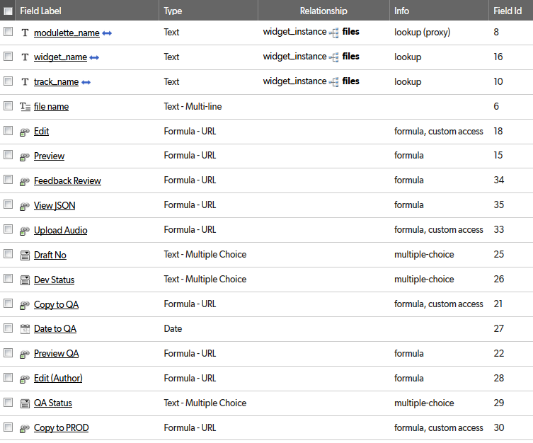

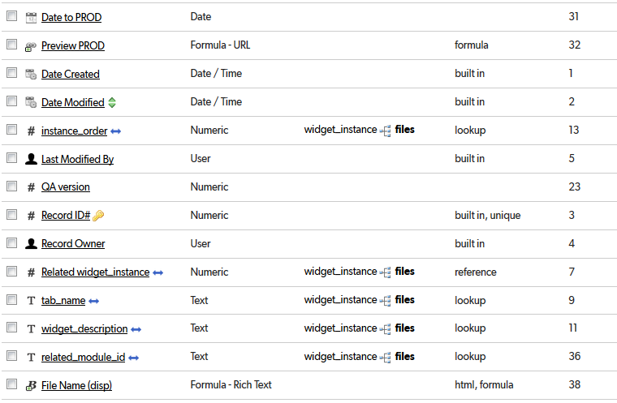

## Relationships

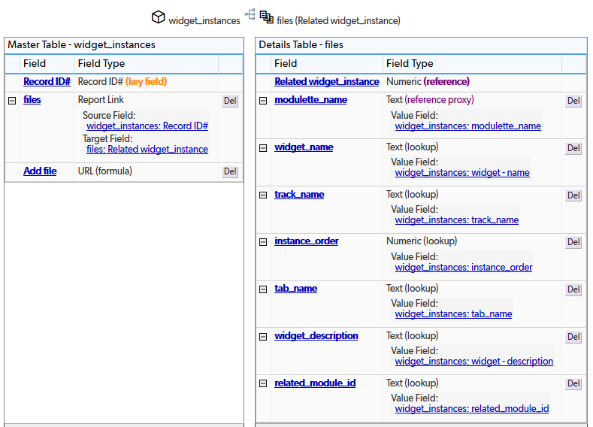

## Field settings

Note: Built-in fields use the default settings

modulette_name 5

widget_name 6

track_name 7

file name 8

Edit 9

Preview 11

Feedback Review 12

View JSON 13

Upload Audio 14

Draft No 15

Dev Status 17

Copy to QA 18

Date to QA 20

Preview QA 21

Edit (Author) 22

QA Status 24

Copy to PROD 25

Date to PROD 27

Preview PROD 28

instance_order 30

QA version 32

Related widget_instance 34

tab_name 36

widget_description 37

related_module_id 38

File Name (disp) 39

# modulette_name

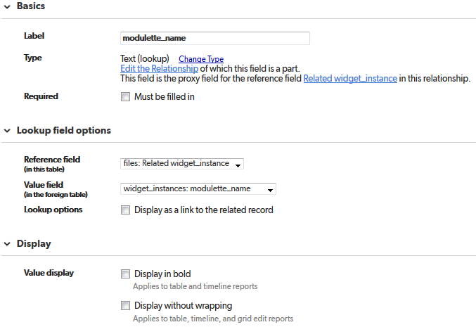

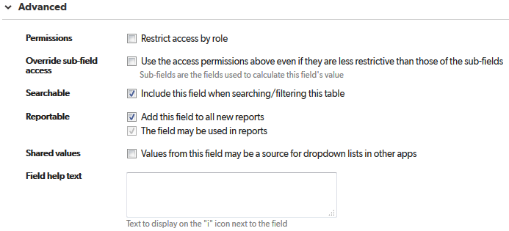

# widget_name

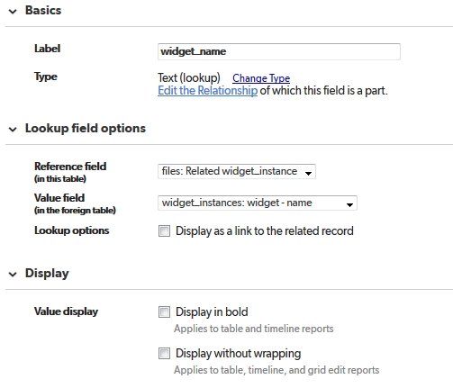

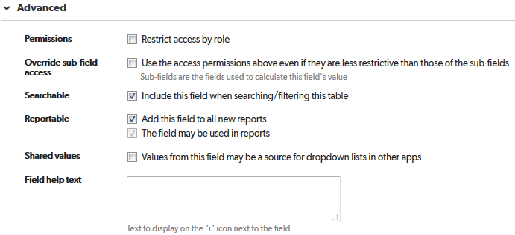

# track_name

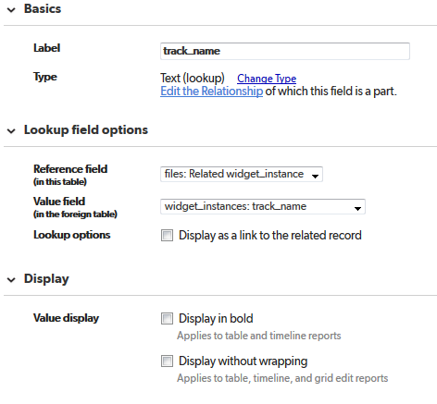

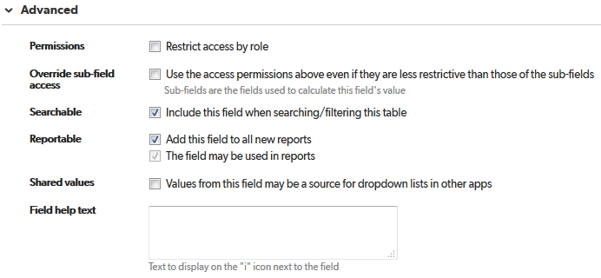

# file name

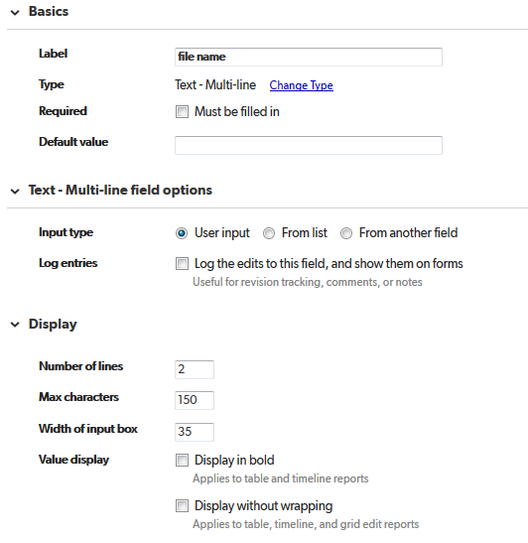

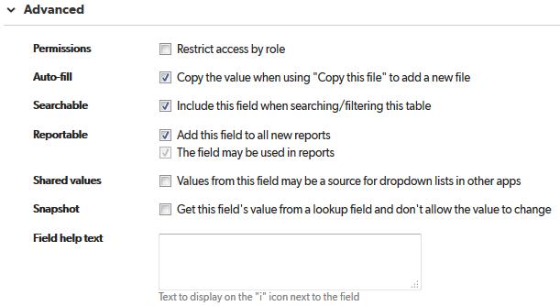

This field allows files to be edited even if their status is “Locked.” You may want to display this to users with an “admin” role.

# Edit

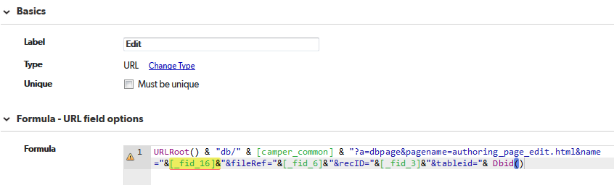

URLRoot() & "db/" & [camper_common] & "?a=dbpage&pagename=authoring_page_edit.html&name="&[_fid_16]&"&fileRef="&[_fid_6]&"&recID="&[_fid_3]&"&tableid="& Dbid()

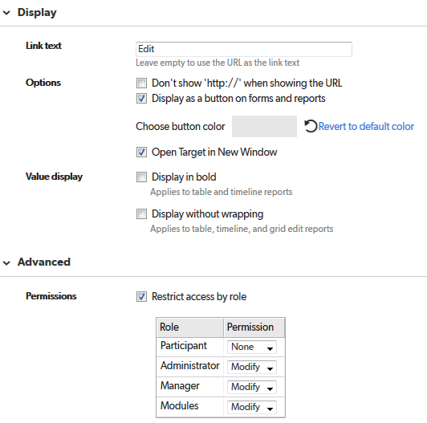

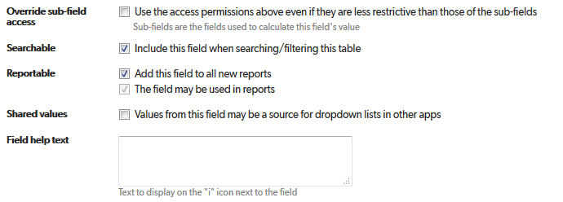

# Preview

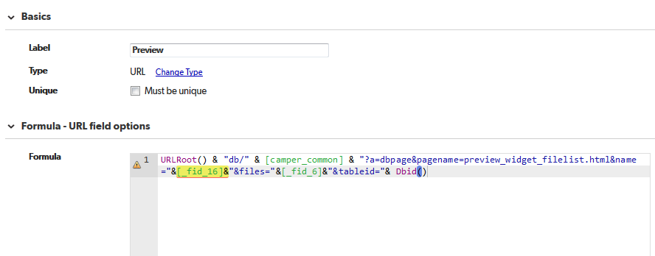

URLRoot() & "db/" & [camper_common] & "?a=dbpage&pagename=preview_widget_filelist.html&name="&[_fid_16]&"&files="&[_fid_6]&"&tableid="& Dbid()

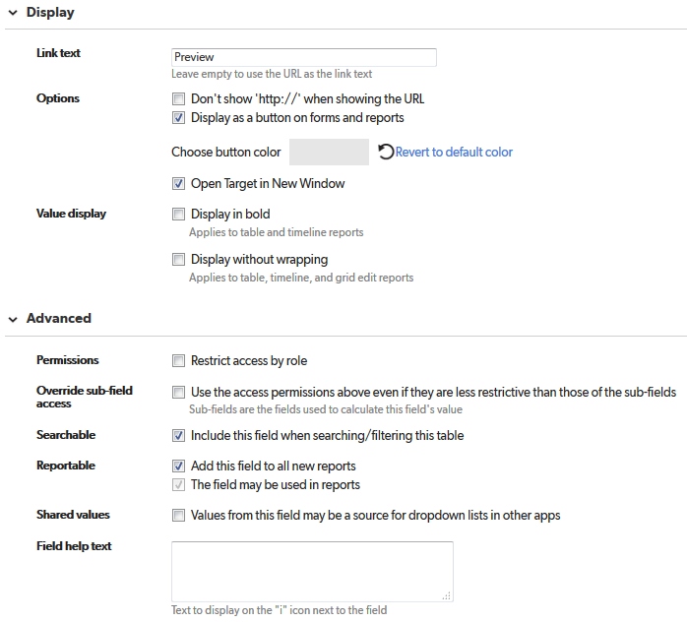

# Feedback Review

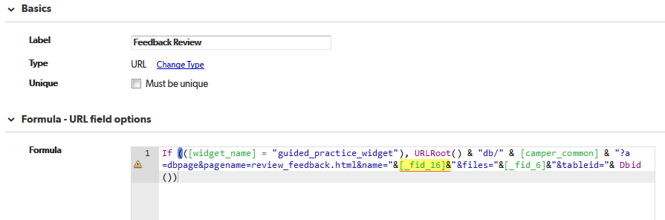

If (([widget_name] = "guided_practice_widget"), URLRoot() & "db/" & [camper_common] & "?a=dbpage&pagename=review_feedback.html&name="&[_fid_16]&"&files="&[_fid_6]&"&tableid="& Dbid())

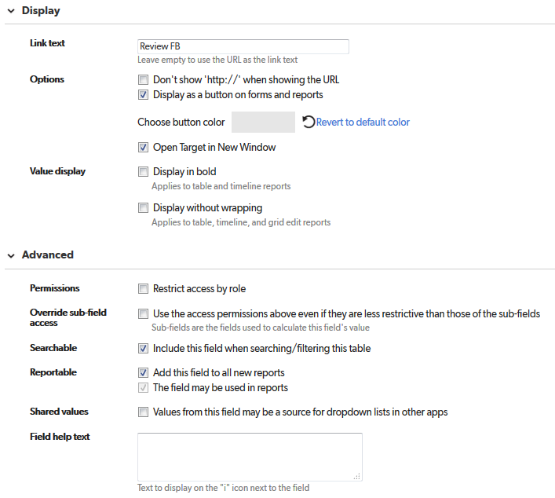

# View JSON

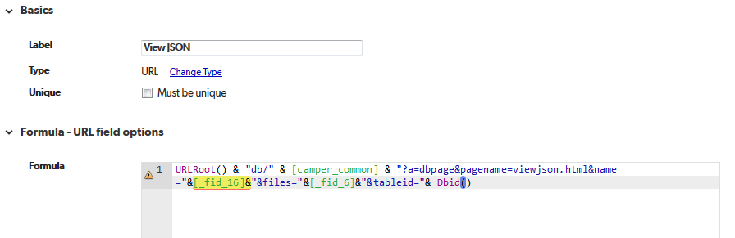

URLRoot() & "db/" & [camper_common] & "?a=dbpage&pagename=viewjson.html&name="&[_fid_16]&"&files="&[_fid_6]&"&tableid="& Dbid()

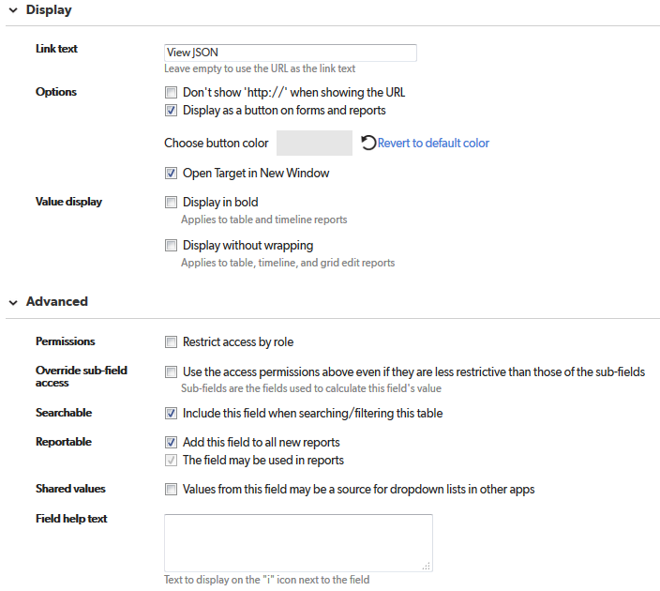

# Upload Audio

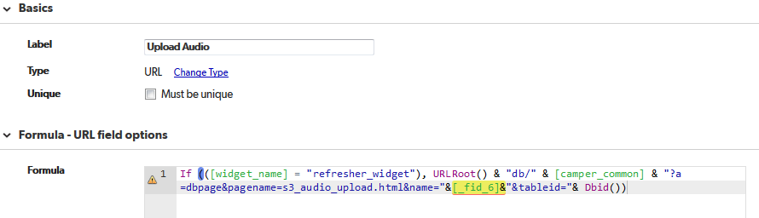

If (([widget_name] = "refresher_widget"), URLRoot() & "db/" & [camper_common] & "?a=dbpage&pagename=s3_audio_upload.html&name="&[_fid_6]&"&tableid="& Dbid())

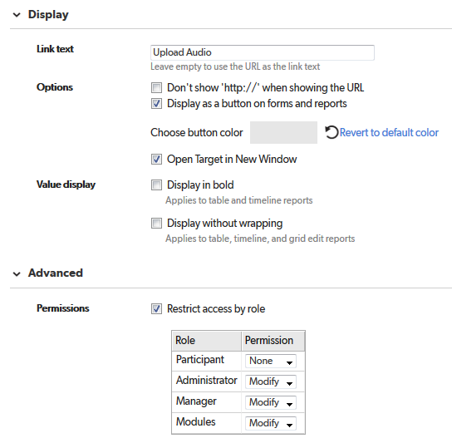

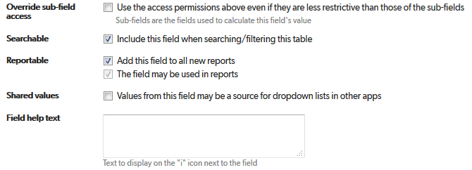

# Draft No

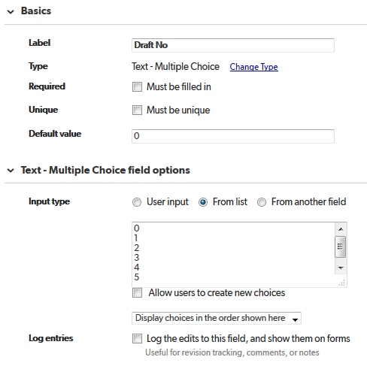

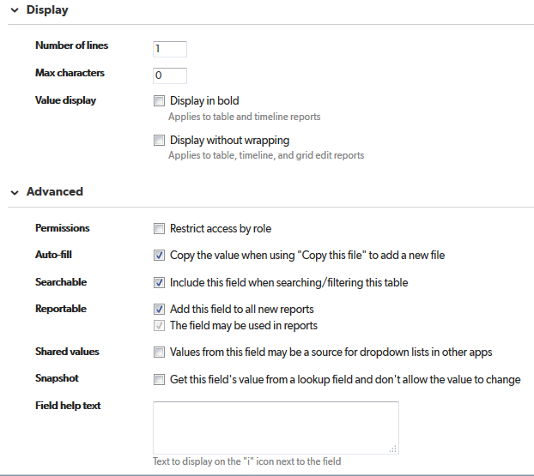

# Dev Status

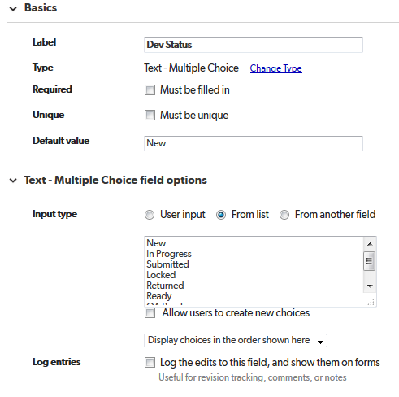

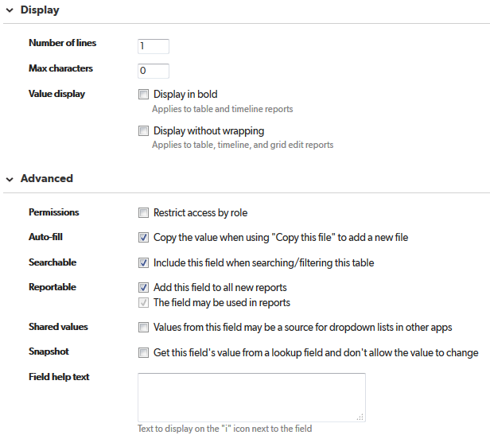

# Copy to QA

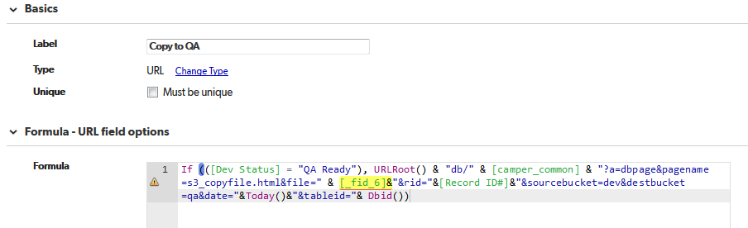

If (([Dev Status] = "QA Ready"), URLRoot() & "db/" & [camper_common] & "?a=dbpage&pagename=s3_copyfile.html&file=" & [_fid_6]&"&rid="&[Record ID#]&"&sourcebucket=dev&destbucket=qa&date="&Today()&"&tableid="& Dbid())

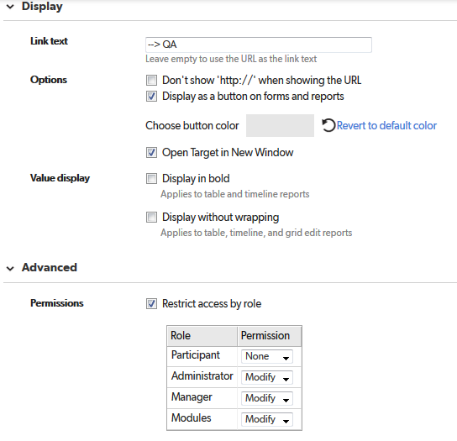

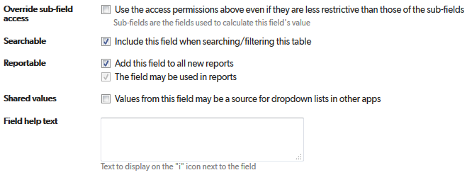

# Date to QA

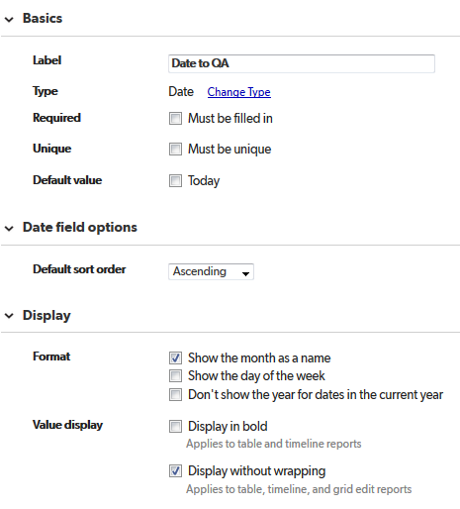

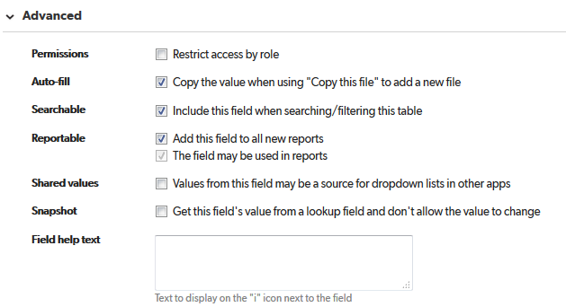

# Preview QA

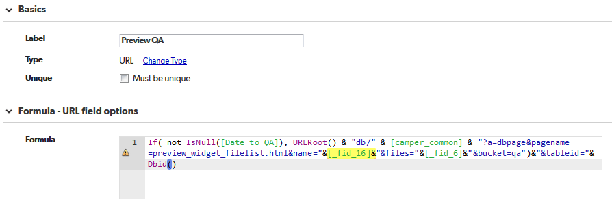

If( not IsNull([Date to QA]), URLRoot() & "db/" & [camper_common] & "?a=dbpage&pagename=preview_widget_filelist.html&name="&[_fid_16]&"&files="&[_fid_6]&"&bucket=qa")&"&tableid="& Dbid()

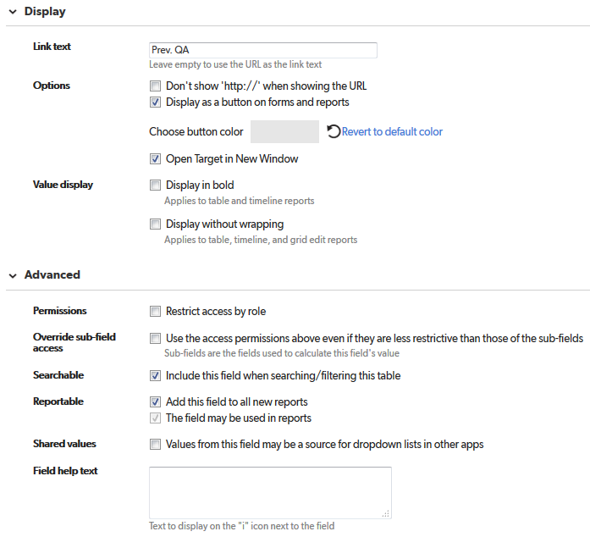

# Edit (Author)

This field does not allow files to be edited if their status is “Locked.” You may want to display this to users with an “authoring” role.

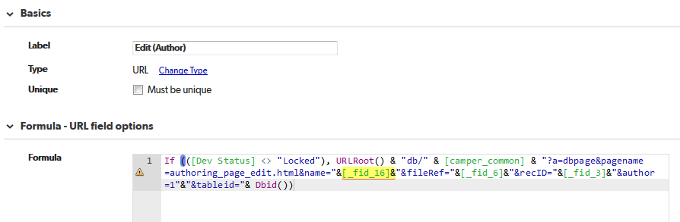

If (([Dev Status] <> "Locked"), URLRoot() & "db/" & [camper_common] & "?a=dbpage&pagename=authoring_page_edit.html&name="&[_fid_16]&"&fileRef="&[_fid_6]&"&recID="&[_fid_3]&"&author=1"&"&tableid="& Dbid())

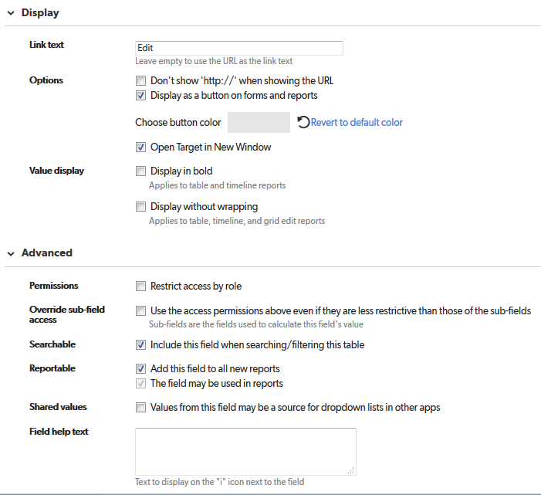

# QA Status

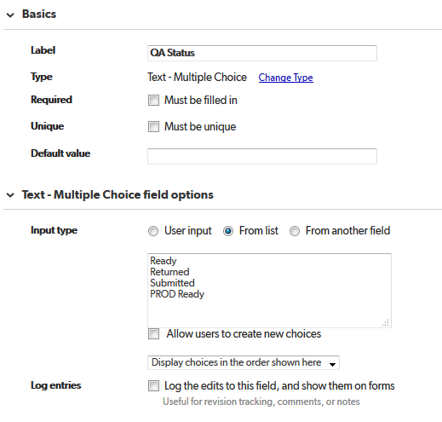

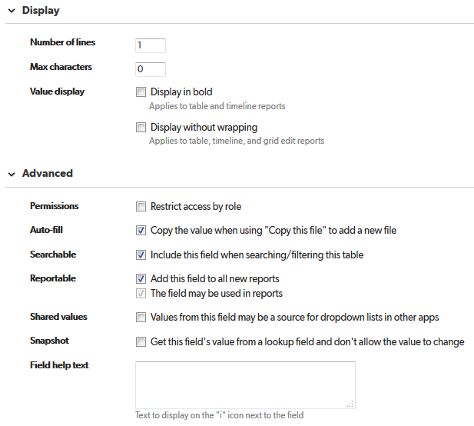

# Copy to PROD

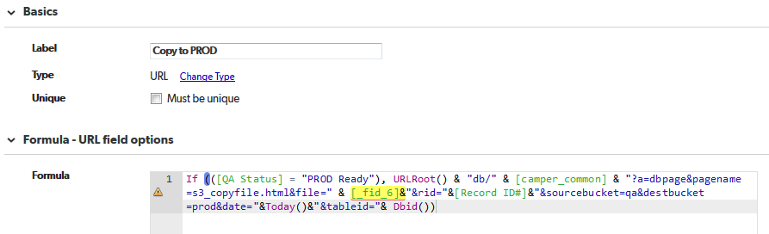

If (([QA Status] = "PROD Ready"), URLRoot() & "db/" & [camper_common] & "?a=dbpage&pagename=s3_copyfile.html&file=" & [_fid_6]&"&rid="&[Record ID#]&"&sourcebucket=qa&destbucket=prod&date="&Today()&"&tableid="& Dbid())

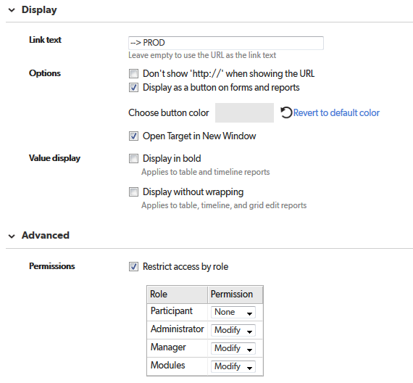

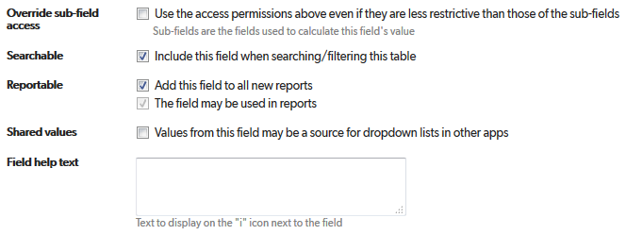

# Date to PROD

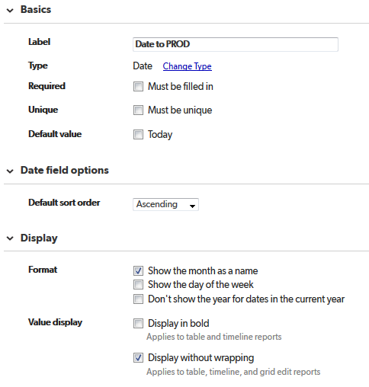

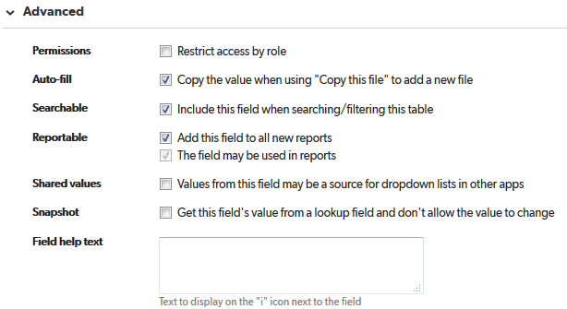

# Preview PROD

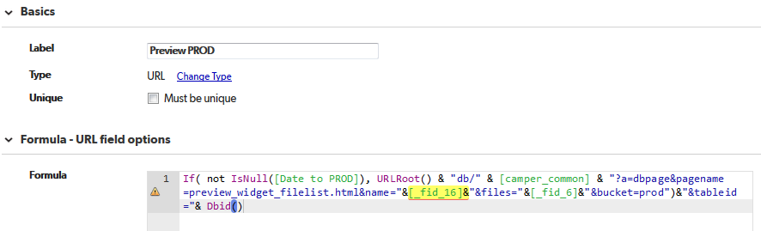

If( not IsNull([Date to PROD]), URLRoot() & "db/" & [camper_common] & "?a=dbpage&pagename=preview_widget_filelist.html&name="&[_fid_16]&"&files="&[_fid_6]&"&bucket=prod")&"&tableid="& Dbid()

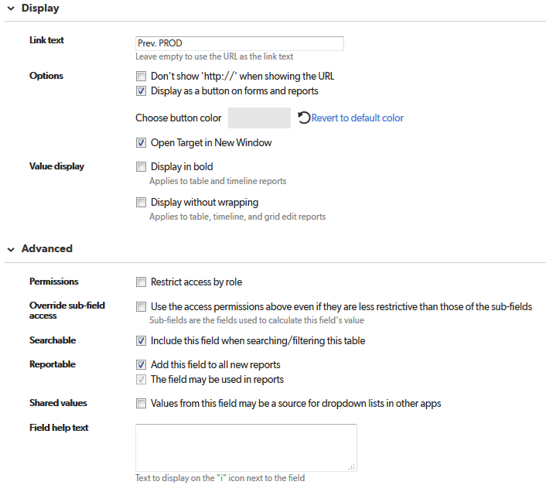

# instance_order

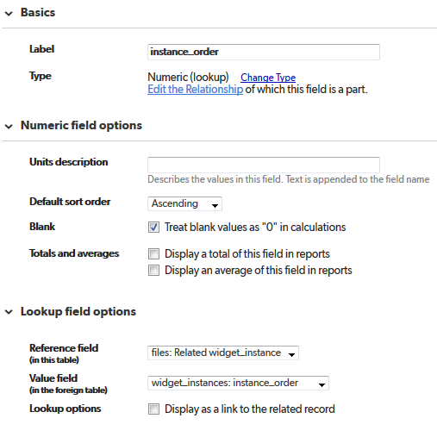

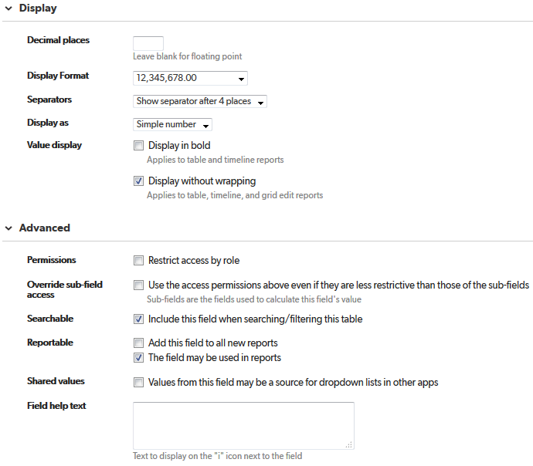

# QA version

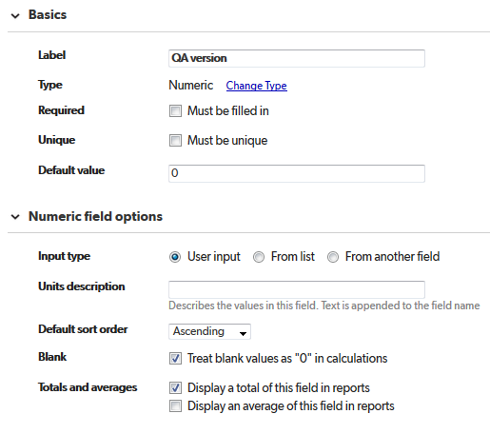

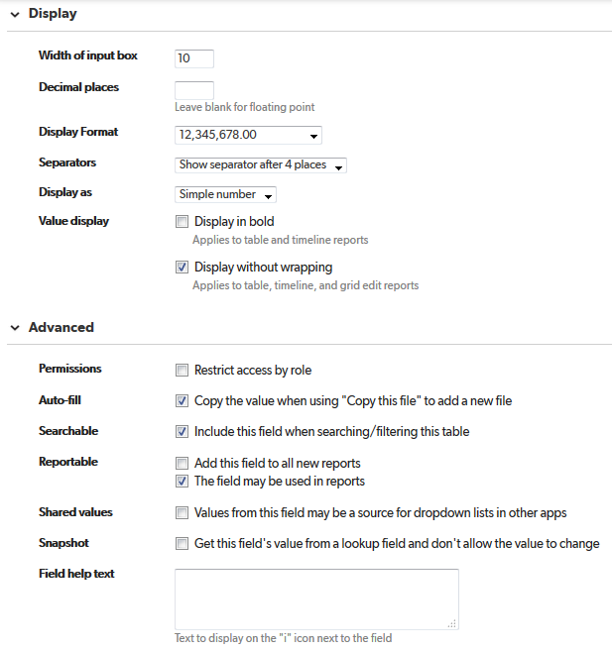

# Related widget_instance

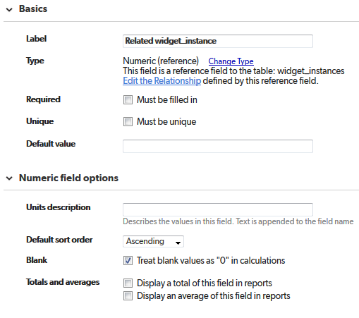

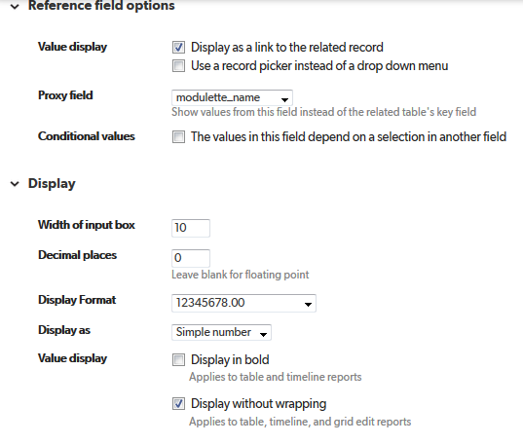

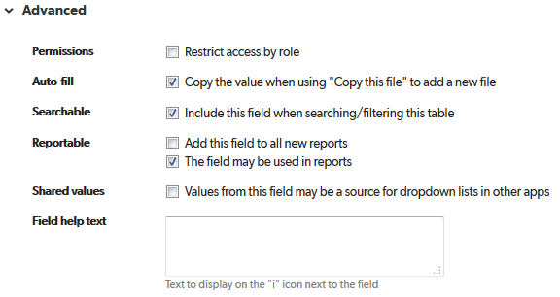

# tab_name

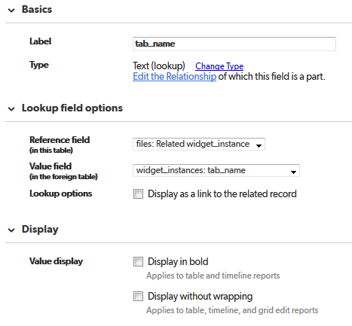

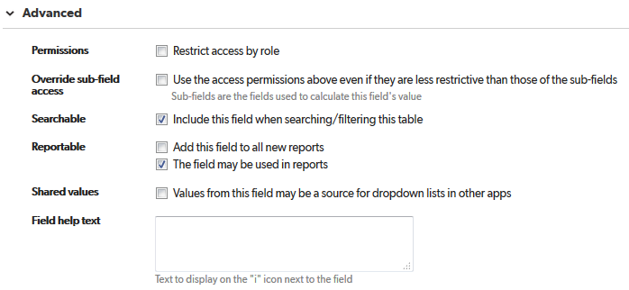

# widget_description

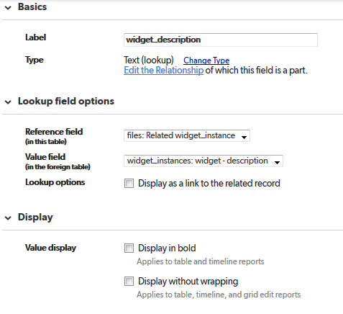

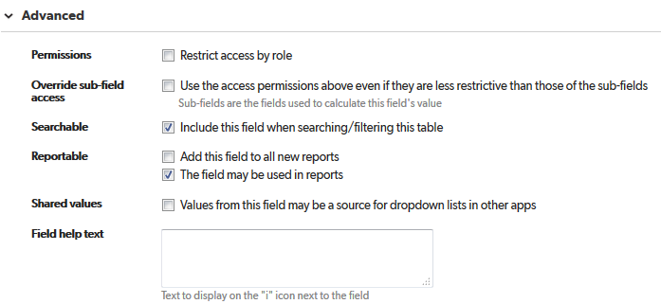

# related_module_id

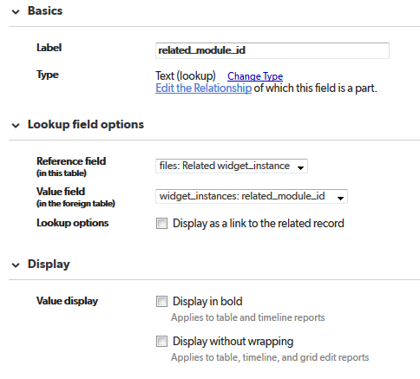

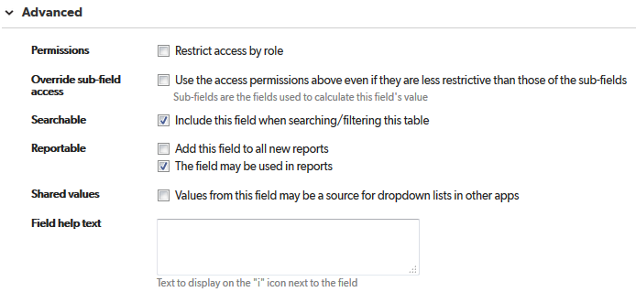

# File Name (disp)

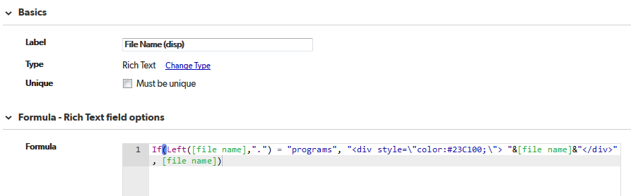

If(Left([file name],".") = "programs", "<div style=\"color:#23C100;\"> "&[file name]&"</div>", [file name])

